ASSIGNMENT 2.1

Task-1:

Code:

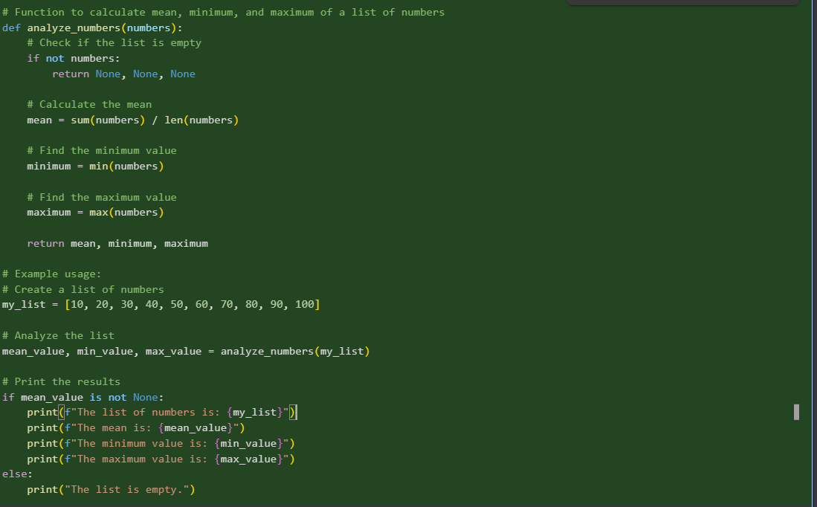

Explanation:

The code defines a function analyze_numbers that takes a list of numbers as input and returns their mean, minimum, and maximum values. It first checks if the list is empty to avoid errors. Then, it calculates the mean by summing the numbers and dividing by the count, finds the minimum and maximum using the built-in min() and max() functions, and finally returns these three values. The example usage demonstrates how to call this function with a sample list and print the results

Result:

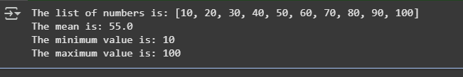

Task-2:

Gemini:

Code:

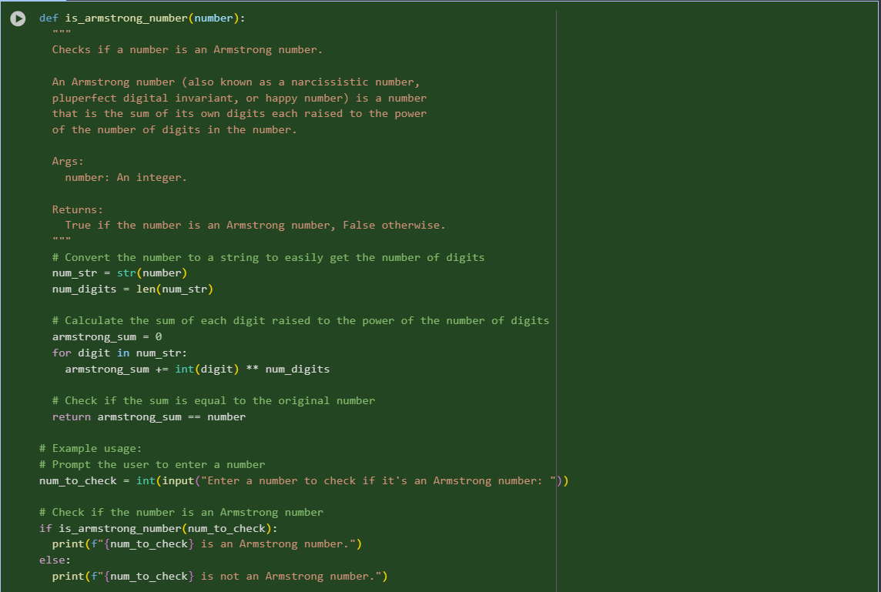

Result:





Copilot:

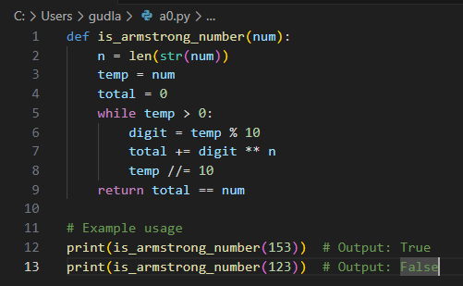

Result:

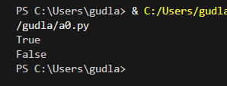

Task-3:

Code:

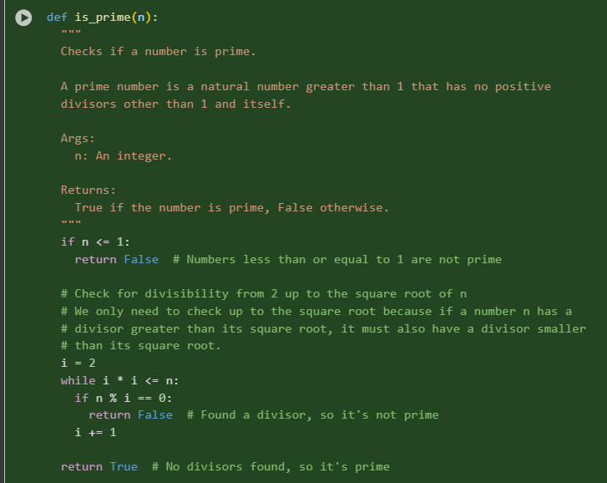

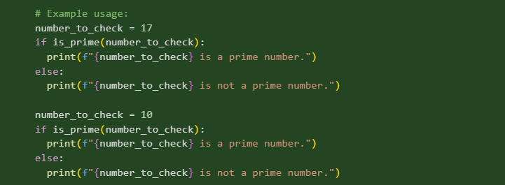

Result:



Task-4:

Cursor:

Code:

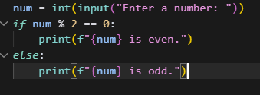

Result:

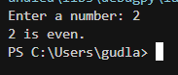

Task-5:

Student code: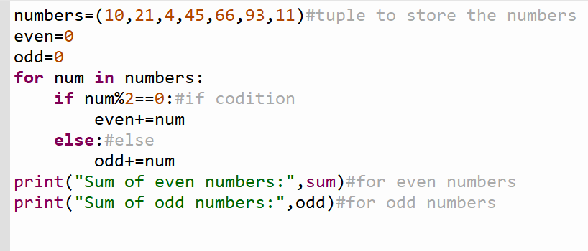

Result:

